Database Final Project
By: Andrew Prescod and Alexis Negron
Class: Database Systems CMP 420
Course Number: E401
Date: May 14, 2024

Introduction
The objective of the final project is to create a database for the School of the Natural and the Social Sciences (NSS) based on its mini world or Universe of Discourse. An EER diagram and a relational model was created to create the concept and the logical model of the database. We then normalized our relations from the relational model to BCNF to then be used for data implementation. MYSQL is the relational database software used to implement the database that can be used to store, retrieve, update and delete data regarding the school.
There were some additional assumptions made besides the constraints that were already specified. We included some additional attributes such as ssn for employees and students which should be unique value among all of them. A department’s location was also included to be multi valued as departments could have multiple locations for their operations so an additional table for the relational model and SQL were created.

EER diagram
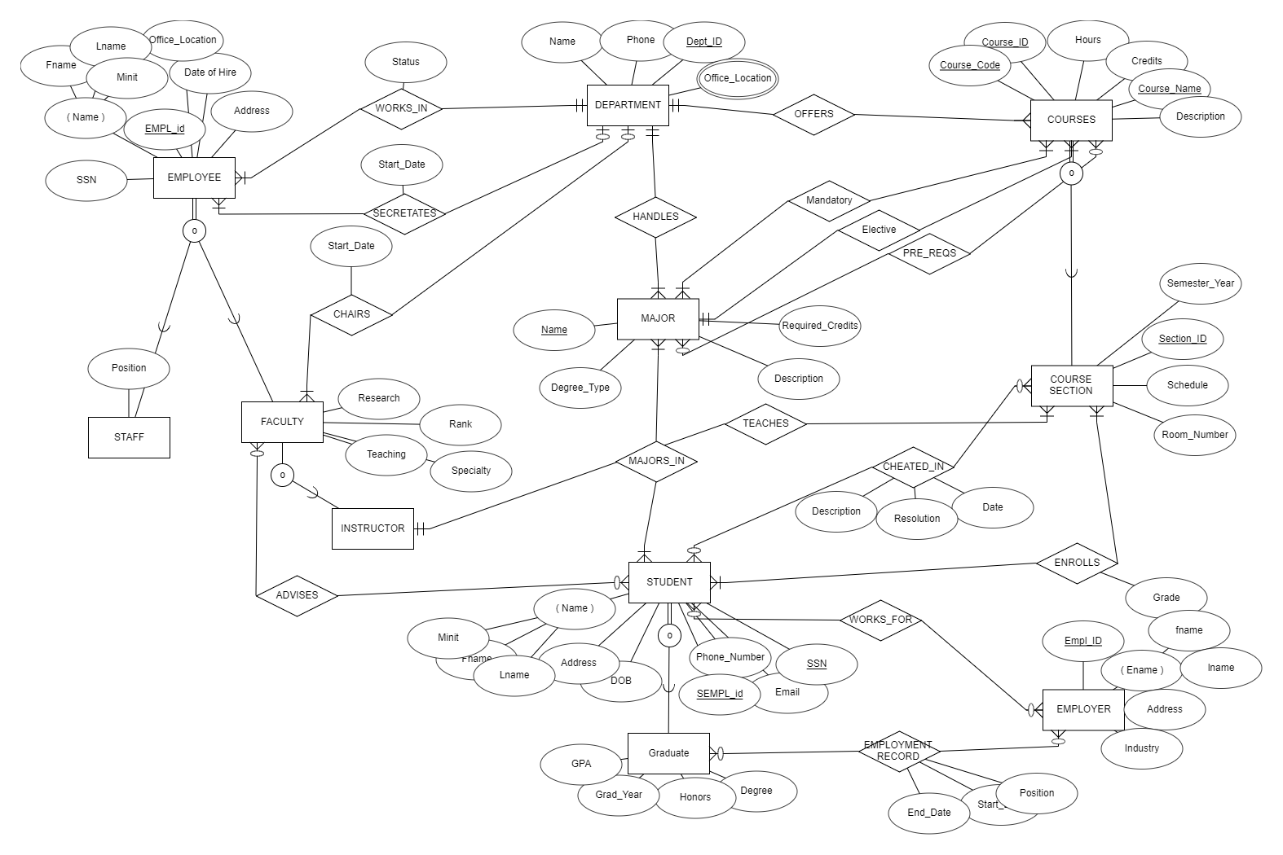
This is the EER diagram that was created. Eleven entities were created with nearly all having one or multiple relationships with other entities. The main approach to this was to create the essential entities and their attributes first such as Department, Employee, Major, and Student. Next, sub-entities or any entities that are an extension of the previous entity were created such as Faculty, Graduate and Course_Section. Mapping the entity together with different relationships and organizing the diagram took most of the time. Participation and cardinality constraints was the last aspects added onto the diagram,

Relational Model
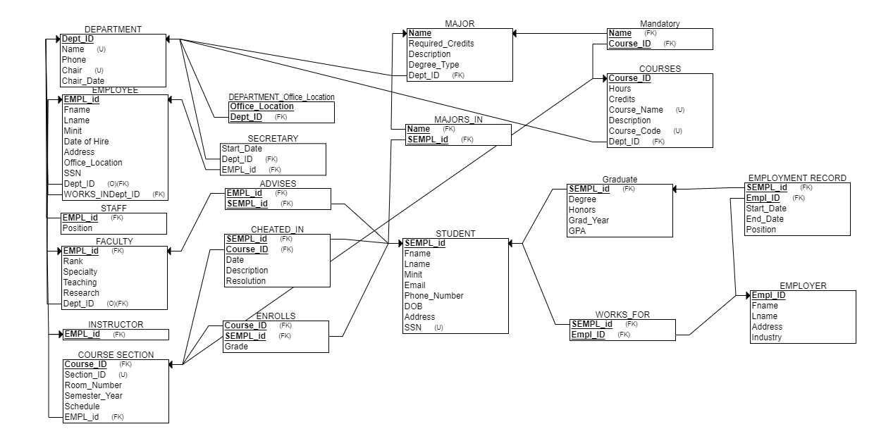
The diagram above is the corresponding relational model for the NSS database. The relational model is generally easier to create when having the EER model as a base. The creation of each relation and their own specific attributes are first created. For example, the relation, Major, has its main attributes, name, required_credits, description and degree_type. Next, foreign keys and new tables are added or generated based on the binary relationships associated with the entities in the EER diagram.

Normalization

Functional Dependencies:
- DEPARTMENT:
  - Dept_ID -> Name, Chair, Phone, Chair_Date
- MAJOR:
  - Dept_ID -> Name, Required_Credits, Description, Degree_Type
  - Name, Dept_ID -> Required_Credits, Description, Degree_Type
- MANDATORY:
  - Major_Name -> Course_ID
- PRE_REQ
  - Major_Name -> Course_ID
- COURSES:
  - Course_ID -> Hours, Credits, Course_Name, Description, Course_Code, Dept_ID
- MAJORS_IN:
  - SEmpl_ID, Name, Dept_ID -> (No additional attributes)
- EMPLOYEE:
  - Empl_ID -> Fname, Lname, Minit, Date_of_Hire, Address, Office_Location, SSN
- SECRETARY:
  - Empl_ID -> Dept_ID, Start_Date
- ADVISES:
  - Empl_ID, SEMPL_ID -> (No additional attributes)
- FACULTY:
  - Empl_ID -> Rank, Specialty, Teaching, Research, Dept_ID
- CHEATED_IN:
  - SEmpl_ID, Course_ID -> Date, Description, Resolution
- STUDENT:
  - SEMPL_ID -> Fname, Lname, Minit, Email, Phone_Number, DOB, Address, SSN
- ENROLLS:
  - Course_ID, SEMPL_ID -> Grade
- INSTRUCTOR:
  - EMPL_ID -> (No additional attributes)
- COURSE_SECTION:
  - Course_ID, Section_ID -> Room_Number, Semester_Year, Schedule, EMPL_ID
- GRADUATE:
  - SEMPL_ID -> Degree, Honors, Grad_Year, GPA
- EMPLOYMENT_RECORD:
  - SEMPL_ID -> Empl_ID, Start_Date, End_Date, Position
- WORKS_FOR:
  - Empl_ID, SEMPL_ID -> (No more additional attributes)
- EMPLOYER:
  - Empl_ID -> Fname, Lname, Address, Industry
- STAFF:
  - Empl_ID -> Position (No additional attributes)
- DEPARTMENT_OFFICE_LOCATION
  - Dept_ID -> Office_Location
BCNF Decomposition:
- DEPARTMENT (Dept_ID, Name, Chair, Phone, Chair_Date)
  - This relation is in BCNF.
- MAJOR (Dept_ID, Name, Required_Credits, Description, Degree_Type)
  - Decompose into:
  - MAJOR1 (Dept_ID, Name, Required_Credits, Description, Degree_Type) MAJOR2 (Name, Dept_ID, Required_Credits, Description, Degree_Type)
- MANDATORY (Course_ID, Name)
  - This relation is in BCNF.
- PRE_REQS (Major_Name Course_ID)
  - This relation is in BCNF.
- COURSES (Course_ID, Hours, Credits, Course_Name, Description, Course_Code, Dept_ID)
  - This relation is in BCNF.
- MAJORS_IN (SEMPL_ID, Name, Dept_ID)
  - This relation is in BCNF.
- EMPLOYEE (EMPL_ID, Fname, Lname, Minit, Date_of_Hire, Address, Office_Location, SSN)
  - This relation is in BCNF.
- SECRETARY (EMPL_ID, Dept_ID)
- ADVISES (EMPL_ID, SEMPL_ID)
- FACULTY (EMPL_ID, Rank, Specialty, Teaching, Research, Dept_ID)
- CHEATED_IN (SEMPL_ID, Course_ID, Date, Description, Resolution)
- STUDENT (SEMPL_ID, Fname, Lname, Minit, Email, Phone_Number, DOB, Address, SSN)
- ENROLLS (Course_ID, SEMPL_ID, Grade)
- INSTRUCTOR (EMPL_ID).
- COURSE_SECTION (Course_ID, Section_ID, Room_Number, Semester_Year, Schedule, EMPL_ID)
- Graduate (SEMPL_ID, Degree, Honors, Grad_Year, GPA)
- EMPLOYMENT_RECORD (SEMPL_ID, Empl_ID, Start_Date, End_Date, Position)
- WORKS_FOR (Empl_ID, SEMPL_ID)
- EMPLOYER (Empl_ID, Fname, Lname, Address, Industry)
- STAFF (EMPL_ID, Position)
- DEPARTMENT_Office_Location (Dept_ID, Office_Location)
For the most part the candidate keys are the first and second attributes for relations that are using two foreign keys. The majority of relations have one attribute determining the rest of the other attributes, most of them being in BCNF.

SQL Queries

CREATE TABLE department (
dept_ID integer(3),
dname varchar(25) not null,
phone varchar(11) not null,
chair_ID integer(8) not null,
chair_date date,
primary key (dept_ID),
key (dname)
);
CREATE TABLE dept_location (
dept_location varchar(15),
dept_ID integer(3),
primary key(dept_location, dept_ID),
foreign key(dept_ID) references department(dept_ID)
);

CREATE TABLE employee (
empl_ID integer(8),
fname varchar(15) not null,
lname varchar(15) not null,
minit varchar(1),
hired date,
address varchar(50),
ssn varchar(9),
job_status varchar(15),
d_ID integer(3),
primary key (empl_id),
key(ssn),
foreign key (d_ID) references department(dept_ID)
);

CREATE TABLE secretary(
sempl_ID integer(8),
dept_ID integer(3),
start_date date,
foreign key(sempl_ID) references employee(empl_ID),
foreign key(dept_ID) references department(dept_ID)
);

CREATE TABLE faculty (
fempl_ID integer(8),
ranks varchar(50),
specialization varchar(50),
research_interest varchar(50),
dID integer(3),
foreign key (fempl_ID) references employee(empl_ID),
foreign key (dID) references department(dept_ID)
);

CREATE TABLE staff(
sempl_ID integer(8),
position varchar(50) not null,
foreign key (sempl_ID) references employee(empl_ID)
);

CREATE TABLE instructor (
iempl_ID integer(8),

foreign key (iempl_ID) references faculty(fempl_ID)
);

CREATE TABLE course(
course_ID integer(5) not null,
cname varchar(40) not null,
dID integer(3),
ccode integer(4) not null,
hours integer(1),
credits integer(1),
desci varchar(100),
mname varchar(25),

primary key(course_ID, cname, ccode),
foreign key(mname) references major(mname),
foreign key(dID) references department(dept_ID)
);

CREATE TABLE course_section(
course_ID integer(5) not null,
section_ID integer(4),
room integer(4),
semester varchar(10),
timeFrame varchar(12),
inst_ID integer(8),

primary key(section_ID),
foreign key(inst_ID) references instructor(iempl_ID),
foreign key(course_ID) references course(course_ID)
);

CREATE TABLE student(
sempl_ID integer(8),
fname varchar(15) not null,
lname varchar(15) not null,
minit varchar(1),
email varchar(25),
phone varchar(11),
dob date,
address varchar(50),
ssn char(9),
primary key (sempl_ID),
key(ssn)
);

CREATE TABLE graduate(
sempl_ID integer(8),
degree varchar(25) not null,
honors boolean,
gradyear integer(4),
gpa float(4),
foreign key(sempl_ID) references student(sempl_ID)
);

CREATE TABLE major(
mname varchar(25),
req_credits integer(3),
descr varchar(50),
degree_type varchar(2),
dept_ID integer(3),
primary key(mname, degree_type),
foreign key(dept_ID) references department(dept_ID)
);

CREATE TABLE major_in(
sempl_ID integer(8),
mname varchar(25),
foreign key(sempl_ID) references student(sempl_ID),
foreign key(mname) references major(mname)
);

CREATE TABLE mandatory(
mname varchar(25),
course_ID integer(5) not null,
foreign key(mname) references major(mname),
foreign key(course_ID) references course(course_ID)
);

CREATE TABLE prereqs(
mname varchar(25),
course_ID integer(5) not null,
foreign key(mname) references major(mname),
foreign key(course_ID) references course(course_ID)
);

CREATE TABLE enroll(
course_ID integer(5),
sempl_ID integer(8),
grade varchar(3),
foreign key(course_ID) references course_section(course_ID),
foreign key(sempl_ID) references student(sempl_ID)
);

CREATE TABLE cheat(
course_ID integer(5),
sempl_ID integer(8),
cdate date,
descr varchar(30),
resolve varchar(30),

foreign key(course_ID) references course_section(course_ID),
foreign key(sempl_ID) references student(sempl_ID)

);

CREATE TABLE advise(
empl_ID integer(7),
sempl_ID integer(8),
foreign key(empl_ID) references faculty(fempl_ID),
foreign key(sempl_ID) references student(sempl_ID)
);

CREATE TABLE employer(
empl_ID integer(7),
fname varchar(15) not null,
lname varchar(15) not null,
minit varchar(1),
address varchar(50),
industry varchar(25),
primary key(empl_ID)
);
CREATE TABLE employ_record(
sempl_ID integer(8),
empl_ID integer(7),
start_date date,
end_date date,
position varchar(20),

foreign key(sempl_ID) references student(sempl_ID),
foreign key(empl_ID) references employer(empl_ID)
);

CREATE TABLE works_for(
sempl_ID integer(8),
empl_ID integer(7),

foreign key(sempl_ID) references student(sempl_ID),
foreign key(empl_ID) references employer(empl_ID)
);

Conclusion:
My overall experience with this project was overwhelming, a bit tedious and challenging. The project was not too difficult but required a lot of dedicated time. The ER diagram and MYSQL queries required some more logical thinking but most time put into the project was formatting the tables and entities and creating data that can be used to make queries. Most of the difficulty was the time and effort needed to complete the project with SQL taking most of my time. Outside help was kept to a minimum for the most part except when it came to making fake data for SQL. Honestly, my partner and I should have collaborated more and start earlier. We would have likely added more to the project and done the extra credit if we approached the project differently.

